**HOW TO LOGIN TO WEBINAR**

Please use the below link

Registration URL: <https://attendee.gotowebinar.com/register/1752119438791128833>

Webinar ID: 464-727-387

United States: +1 (631) 992-3221   
Audio PIN: Shown after joining the webinar

CLICK ON THE BELOW LINK

Registration URL: <https://attendee.gotowebinar.com/register/1752119438791128833>

ENTER YOUR DETAILS <-CLICK REGISTER

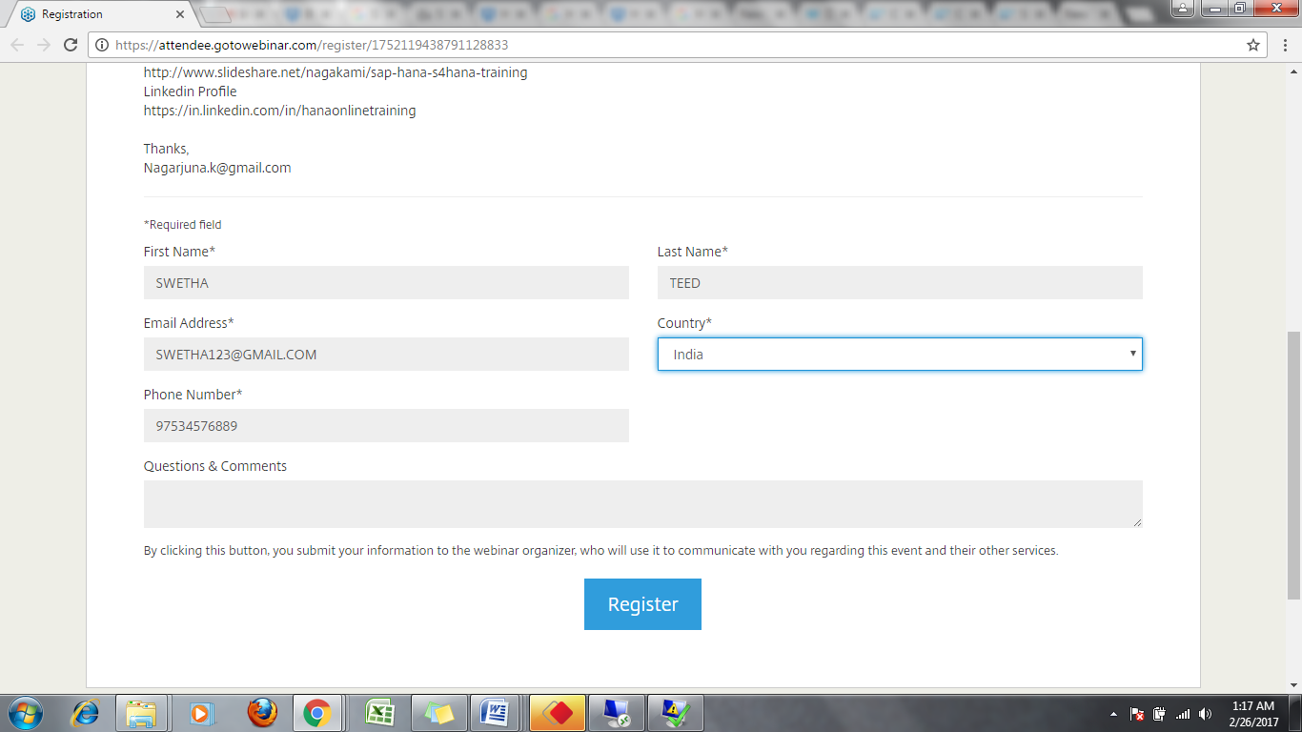

AFTER GETTING REGISTER YOU WILL HAVE THE FOLLOWING SCREEN

<-CLICK ON JOIN THE WEBINAR

OR YOU WILL GET A LINK TO REGISTERED EMAIL ID TO JOIN THE WEBINAR <-CLICK ON THE LINK

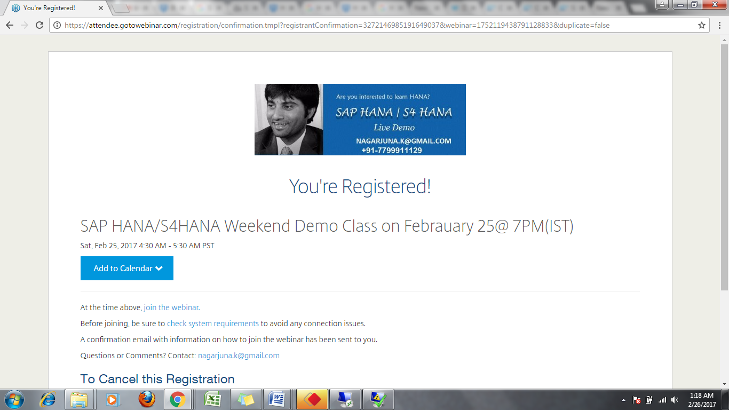AFTER OPENING THE LINK YOU WILL HAVE THE SCREEN WITH DOWNLOAD GOTOWEBINAR<-OPEN THE DOWNLOAD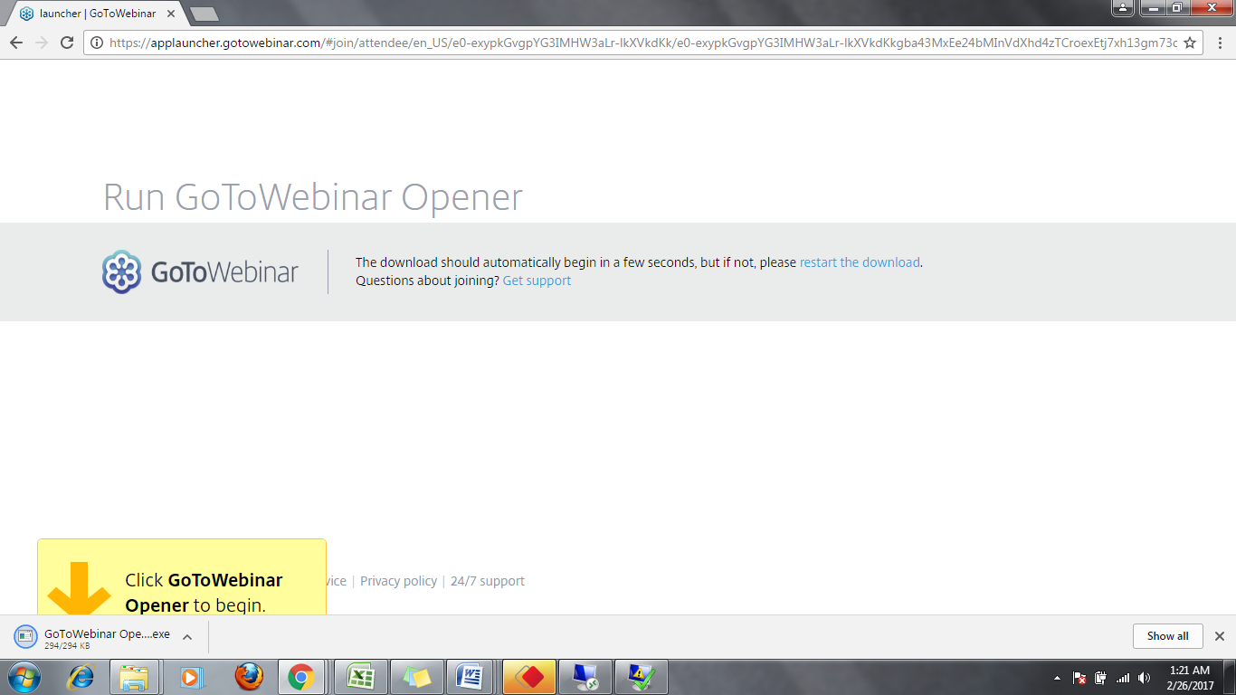ED GOTO WEBINAR <-CLICK ON RUN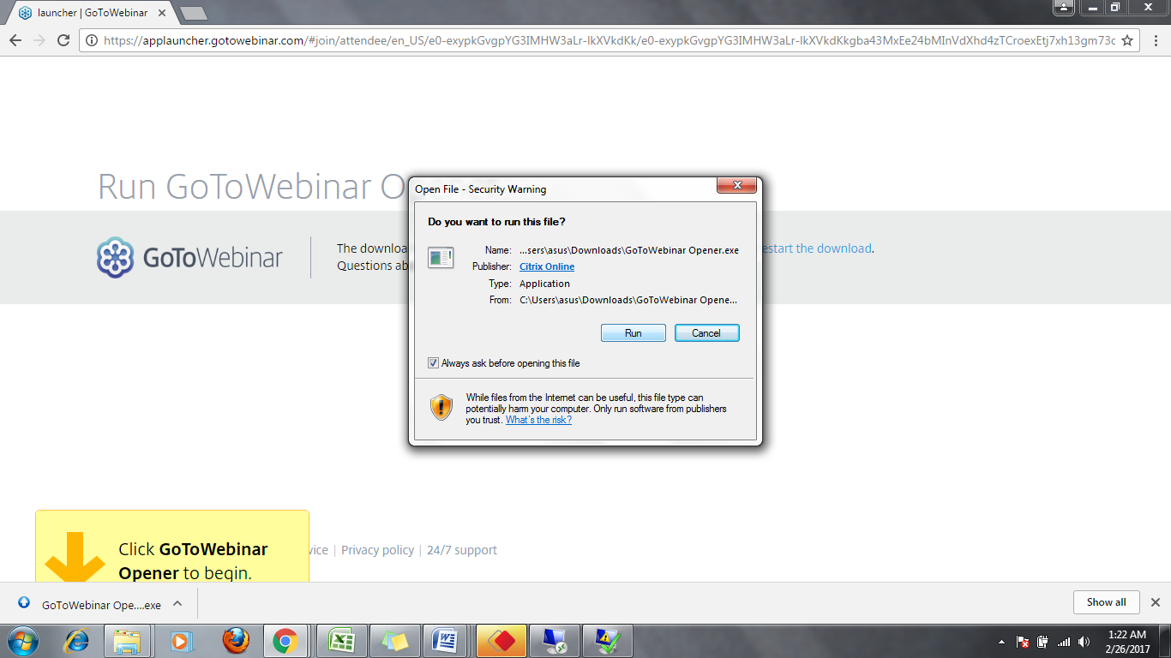 CITRIX ONLINE LAUCHER INISTALLING 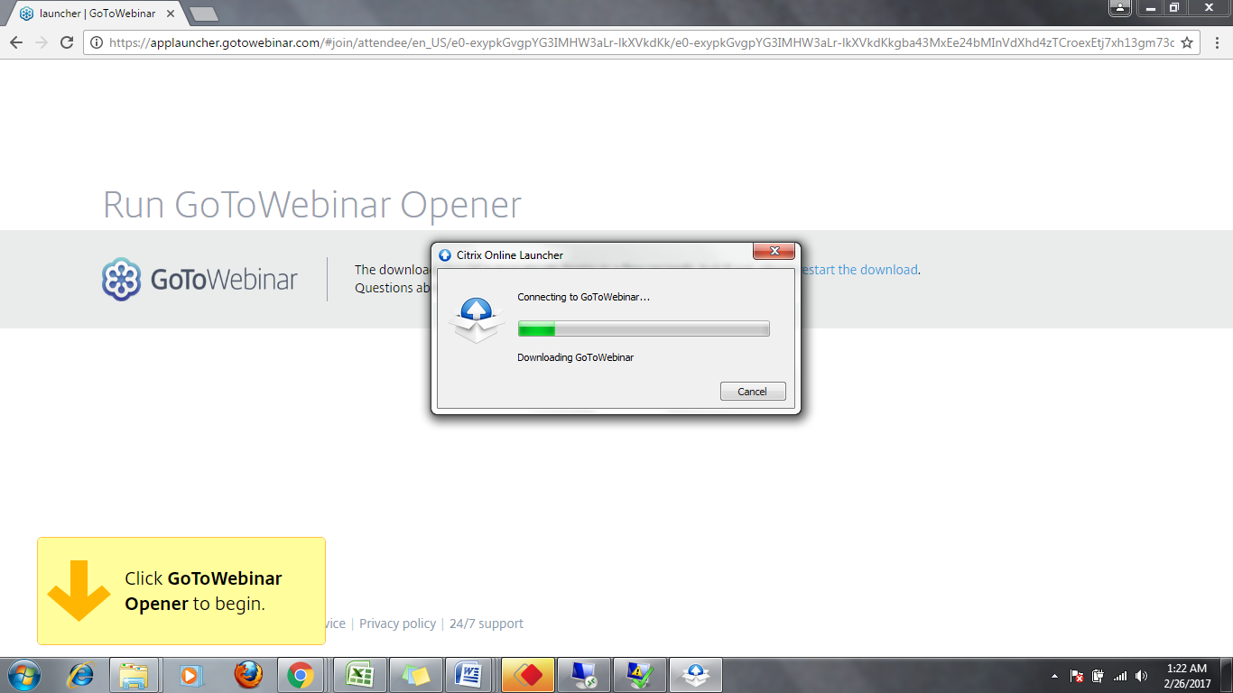

CITRIX ONLINE LAUCHER INISTALLING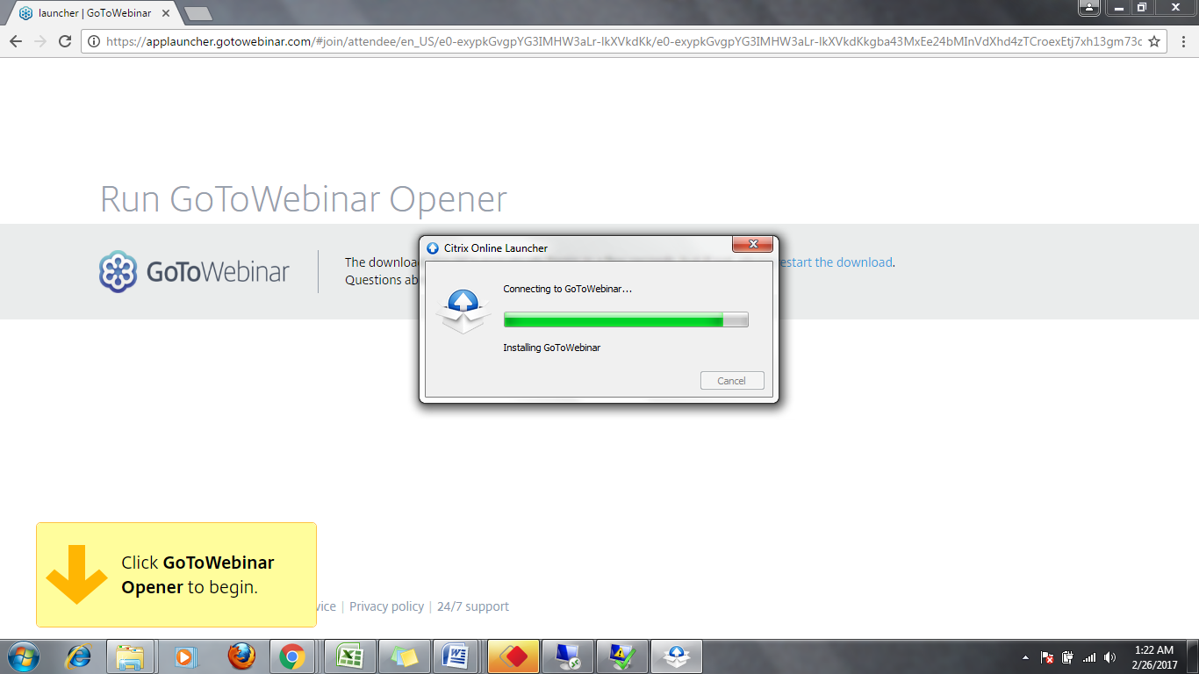

CHOOSE AN AUDIO OPTION<- COMPUTER AUDIO OR PHONE CALL <THEN CLICK<-CLICK OK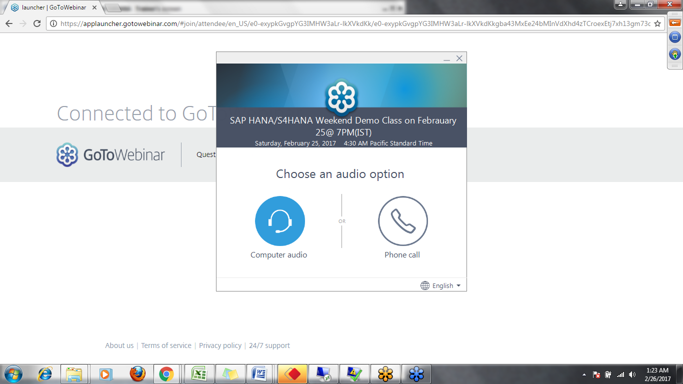

<-CLICK OK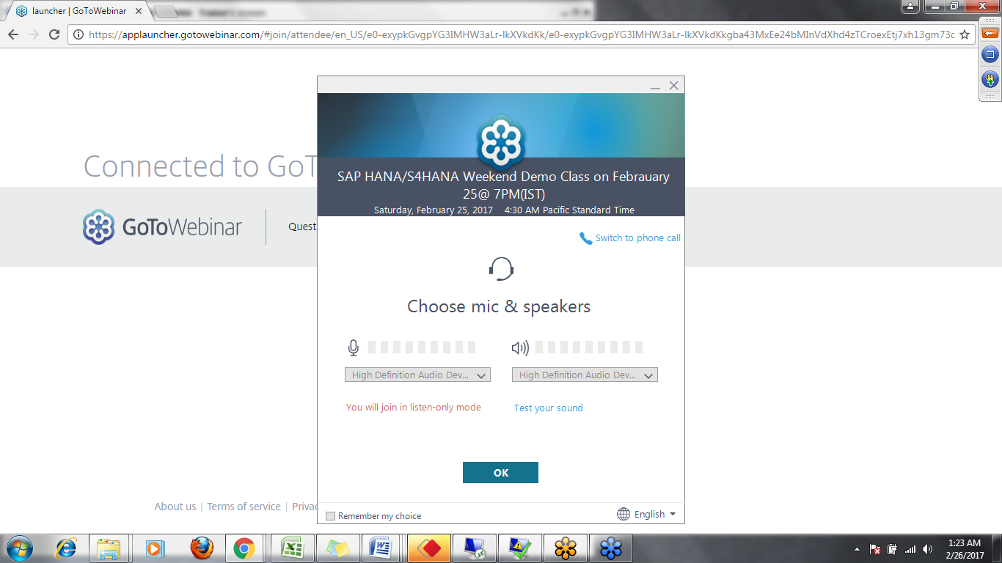

YOU WILL BE ENTERING TO CLASS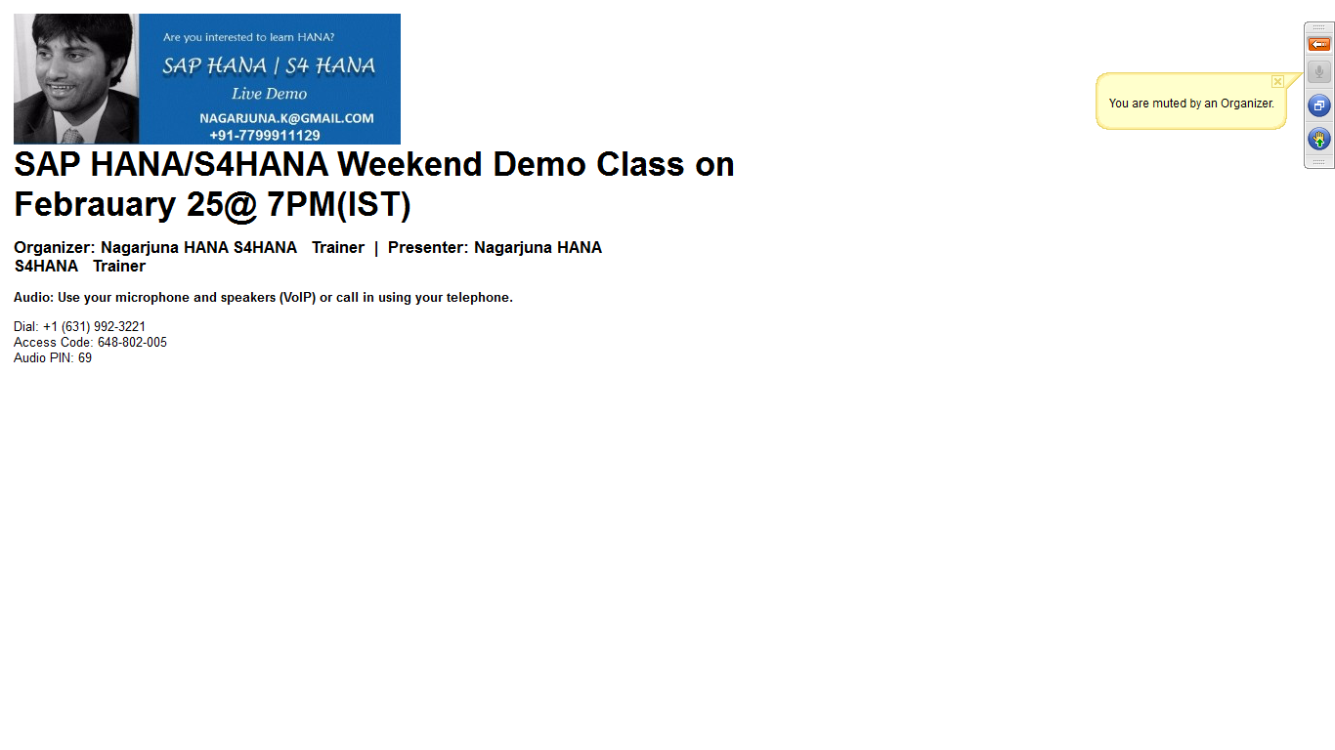

AFTER LOGIN TO THE WEBINAR THE SESSION WILL STARTS IN 10 MINS